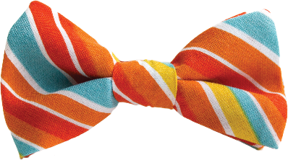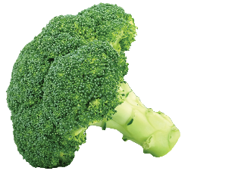

**Table of Contents**

About the Show – Page 1

About the Company – Windmill Theatre – Page 2

Lesson – What Can We Learn from a Box of Crayons? – Page 3

Lesson – What is a Friend?

– Page 5

Lesson – Big Bad/Good Wolf?

– Page 7

More Fun Ideas – Page 9

Actor Bios – Page 10

Excerpts from Windmill Theatre Company’s Teacher Notes guide.

Photos by Tony Lewis.

Compiled and edited by Cassie LaFevor.

Dear Teachers,

Audiences may be familiar with the concept of the “Big Bad Wolf”, but in this performance we find that Wolfie is just a **sweet, vegetable-eating poet, who wants a friend**. Although the characters of Wolfie and Heidi Hood are distantly related to the characters we know from traditional fairy tales, this production tells a **brand new story** of **friendship and being proud of who you are**.

This **unlikely duo** will have you and your students laughing all the way to the end of the show. We know you will love the characters and story of **friendship, bravery, and uniqueness** found in this production brought to you all the way from **Australia by Windmill Theatre Company.**

See you in the theater!

TPAC Education

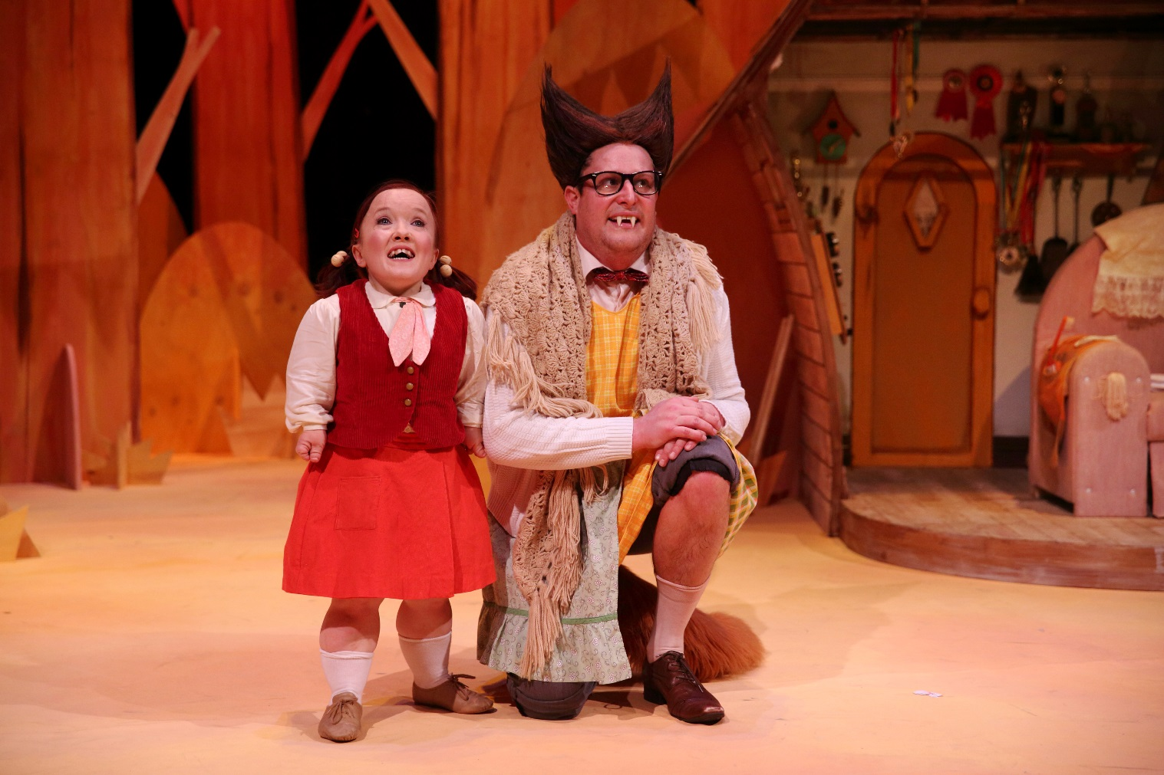



About the Show – Big Bad Wolf

Synopsis

The opening setting is a forest. We meet Wolfie, who has the physical characteristic of a “Big Bad Wolf” but is cut from a different cloth. He is actually quite nice, and a bit of a joke amongst his wolf community as he prefers to eat vegetables instead of humans. More than anything, he would like a friend. Unfortunately, the creatures of the forest are still scared of him, and run in fear when he tries to befriend them.

The next scene brings us to a small house, very neat and perfect and lovely, in the village of Alarmsville. Alarmsville prides itself on being the safest in the whole wide world. This is Heidi Hood’s home, and she has the best alarms in town. As well as being very neat and clean at home, Heidi is very competitive. In fact, Heidi has won all of the competitions in Alarmsville.

Wolfie’s love of writing poetry and a chance for Heidi to win another competition, bring these two unlikely characters together.



**A Different Kind of Wolf**

Audiences may be familiar with the concept of the “Big Bad Wolf” character. However, in this performance we meet Wolfie, a sweet, vegetable-eating poet, who just wants a friend. Although he does have sharp teeth, this wolf comes in last in his “People Scaring” exams, loves broccoli, spouts poetry, and carries around his teddy!

Although the characters of Wolfie and Heidi Hood are distantly related to the characters we know from traditional fairy tales, this production tells a brand new story of friendship and being proud of who you are.

Costume Sketch by Costume and Set Designer for *Big Bad Wolf* - Jonathon Oxlade



About the Company – Windmill Theatre

Windmill Theatre was formed in 2002 as an initiative of the South Australian Government to provide high-quality performance experiences to inspire and enrich the cultural life, learning and imagination of children and families.

Windmill artists are inspired by the vibrancy, sophistication and inventiveness of young people and the exhilarating challenges they pose to creating theatre of genuine relevance in this modern time. In meeting this challenge Windmill Theatre positions theatre for children, young people and families in a dynamic national and international conversation that is defining the future of theatre practice.

http://www.windmill.org.au/

Since its inception, the company has:

* Presented 56 productions made up of 27 new commissioned works, 8 new productions of existing works, the presentation of 19 leading Australian and international companies and has undertaken 55 regional, national and international tours, performing to a total of 500,000 children and their families to date.
* Toured nationally to Melbourne, Brisbane, Perth, Darwin, Canberra, Sydney, Wollongong, and Brisbane.
* Toured internationally to the US, Canada, Scotland, Hong Kong, Korea, New Zealand, Singapore and Japan.
* Produced one feature film, two documentary films and created two mix-media digital projects.





Lesson - What Can we Learn from

A Box of Crayons?

**Introduction:** In *Big Bad Wolf*, Wolfie faces the problem of being seen as something he is not. During the show, he finds that his differences make him special and not something to be ashamed of. This lesson help students discover the value of diversity and to celebrate their own differences.

**Objectives:**

The student will identify and list benefits to diversity.

**Notes from the Writer – Matthew Whittet**

“We all know what it’s like to be misunderstood. For people to look at you and think you are something that you are not. Sometimes your voice is a little different than everyone else because you grew up in a different city, or you walk a little differently than everyone else cause your feet are a different shape, or you’re a lot taller than everyone else because you ate a lot of porridge in the school holidays when your mum told you to. These are the differences that we only really think about when someone else points them out…..Wolfie, our hero in *Big Bad Wolf*, faces this problem every day. He may look scary, but really he’s just a pacifist poet who loves his teddy bear. He’s all alone without a friend in the world because of how he looks and sounds and because of what everyone thinks he is - a big bad wolf.”

The student will compare and contrast their own traits with classmates.

**Materials Needed:** *The Crayon Box that Talked* by Shane Derolf and Michael Letzig, blank paper, crayons, items for comparing (apple, orange, chocolate, lollipop, or other items you choose)

**Instructional Procedures:**

Part 1 – Differences are beautiful!

* Give each student two sheets of drawing paper, and ask them to pick out **one** crayon. Now ask them to draw a picture with only the single crayon.
* After about five minutes, students should set this drawing aside and focus on the second sheet of paper. Now they will be allowed to draw a picture using as many colors as they wish.
* Once they are finished, ask them the following questions: Which picture do you like best? Why? Which picture would you like to display in your classroom, the hallway, at home?
* Most students will prefer the pictures drawn with the whole box of crayons. Point out what a boring world it would be if we were all alike — like the picture drawn with only one crayon. The diversity in the world makes it like a wonderful box of crayons with endless colors. (If one of your students likes the single crayon drawing best, this discussion may celebrate that all of the pictures drawn were unique and different instead of focusing on the colors being the difference.)
* [](http://www.google.com/url?sa=i&rct=j&q=&esrc=s&source=imgres&cd=&cad=rja&uact=8&ved=0ahUKEwiBsuCAhu7KAhWJJCYKHWkPAGAQjRwIBw&url=http://poems-compilation.blogspot.com/2010/02/just-box-of-crayons.html&psig=AFQjCNGCVGvlU1P4zJC8ZbCt3IWQ_UUJOQ&ust=1455222931753318)Next, read the book *The Crayon Box that Talked* aloud to the class. Discuss - Wasn't it silly for the crayons not to like each other just because of their color? Each crayon had something special to offer to the picture — green for the grass, blue for the sky, yellow for the sun.
* What is the value of differences? As a class, can you come up with three reasons that difference and diversity are positive things in our world?

Part 2 - How are ***you*** different and unique?

* Continue the discussion by asking - How are each one of us different? How are we similar?
* To reinforce the vocabulary words for younger students, use concrete items. Display the following items - an apple, orange, chocolate and lollipop. Have students identify which items are similar and explain how they are similar (an apple and orange are fruits, shaped like spheres, juicy; chocolate and lollipop are both sweet, etc.). Then students will find objects that are different (an orange and chocolate) and explain how the items are different.
* Continue with the concept of being different as a good thing, emphasizing the positive of differences. It is our differences that make us UNIQUE and SPECIAL! To help introduce the idea of how we are each different do one of the following quick activities -
  + For younger students - Give the class four or five criteria statements for them to consider, and ask those that fit the criteria to stand up. For example – everyone with brown hair stand up, if you like football stand up, if you are wearing something that is red stand up, everyone with a birthday in April stand up, etc.
  + For older students - Ask for two student volunteers to come and stand in front of the class. Use a Venn diagram to compare the likenesses and differences of the two students. Have the other students ask the volunteers questions about what they like, such as their favorite color, food, toy, etc.
* Now that students have some experience thinking about their differences, ask students to share their thoughts and ideas about what makes us all different and what makes us the same. Brainstorm as a class something about each of you that makes you different and unique.

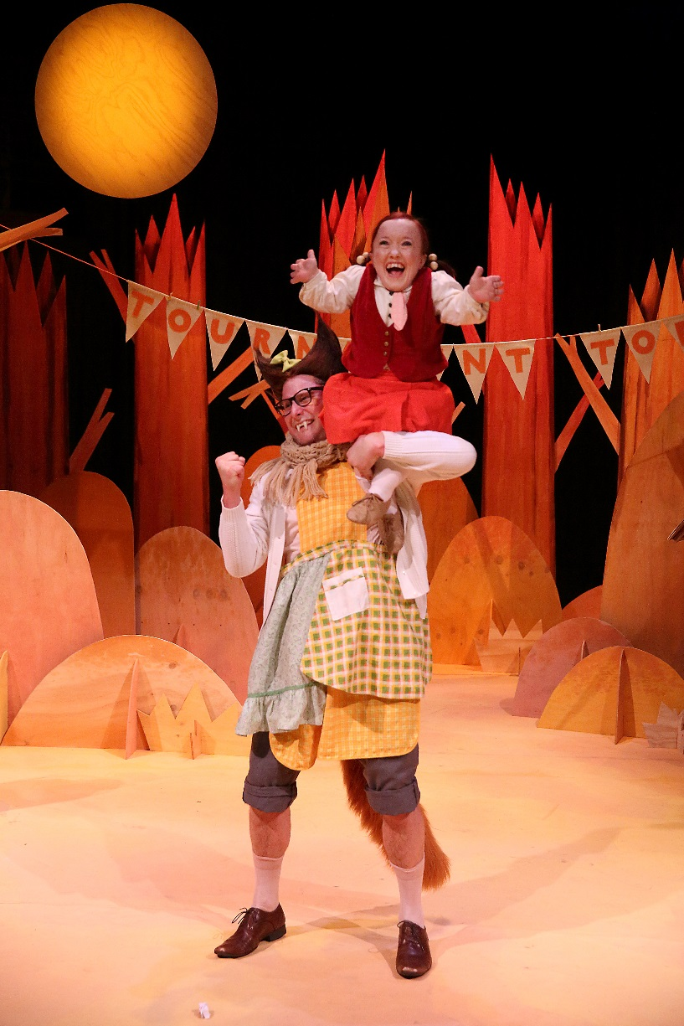**Conclusion** – What might be a consequence of no one daring to be different? Can the children imagine what their lives would be like if everyone always wanted to do the same things, shared the same opinions, liked the same food, went to the same place for their holidays etc.? Together write a class list where each line begins with the words, ‘Imagine if no one ever did anything different…’ (There would be no inventions, no new places to visit, no new people to meet, etc.).

**Extension for older students** - Deepen the discussion by asking if anyone ever made them feel good or bad about this difference like Wolfie. Who and why? Ask each student to choose 1 quality they possess that makes them unique and write about a time this made them feel good.



Lesson – What is a Friend?

**Introduction:** Since he was little, all Wolfie wanted was to have a friend. But every time he asks other animals to be his friend, they are all scared that he will eat them. Heidi Hood seems confident and accomplished, but she doesn’t have any real friends, either. This lesson explores the concept of a good friend.

**Objectives:**  
The student will examine and predict what will happen in *Do You Want to Be My Friend?*

The student will create a list of traits describing a good friend.

The student will write a poem as a class based on friendship.

**Materials Needed**: copy of the book *Do You Want to Be My Friend* by Eric Carle

**Instructional Procedures:**

* Begin class with the book *Do You Want to Be My Friend?* by Eric Carle. Before reading it aloud, show the book to the class and tell them the title, explaining to students that in this story, a small lonely mouse becomes brave and asks other animals that he finds if they will be his friend. Take a picture walk through the book, letting students look closely at each picture and make predictions about which animal is next in the story, discussing the colors of the animals, what the animals appear to be doing, what each animals' response may be and why, why the little mouse keeps running past each animal, etc. End the picture walk after the giraffe is introduced and let students make predictions about the ending.
* Now, read the book aloud to see if the mouse is finally able to find a good friend.
* Group discussion –

**Friends**

*by Jill Eggleston*

Friends share.

Friends care.

We need friends

Everywhere!

* + Discuss the mouse’s search for the perfect friend. What good qualities were in each friend he found?
  + Do you find making new friends easy or difficult?
  + What does it mean to be a good friend to someone?
  + Are you a good friend to your friends?
* Read the poem “Friends” to the class. This poem says that friends share and care. What other traits are important to being a good friend?
* As a class, create a list of traits describing a good friend. (Examples below.)
* Good friends listen to each other.
* Good friends don't put each other down or hurt each other's feelings.
* Good friends try to understand each other's feelings and moods.
* Good friends help each other solve problems.
* Good friends can disagree without hurting each other.
* Good friends are dependable.
* Good friends respect each other.
* Good friends are trustworthy.
* Good friends give each other room to change.
* Good friends care about each other.
* In *Big Bad Wolf,* Wolfie loves to write poetry. He describes poetry as turning your “lovely thoughts into lovely words”. Students will turn their own lovely thoughts into lovely words by writing a class poem about friends that is recorded by the teacher on the board. Teachers may choose to use any poetry form, rhyming, free verse, haiku, etc. depending on the needs and level of students.

**Conclusion** – Ask students if they have ever tried to become friends with someone new or if someone has ever tried to become their friend. When? How could they tell? What did they do (smile, ask to play, say kind words, share, sit nearby, do nice things, etc.)? Ask them to write (or draw) advice for someone who is trying to make a new friend based on the traits of a good friend you have discussed.

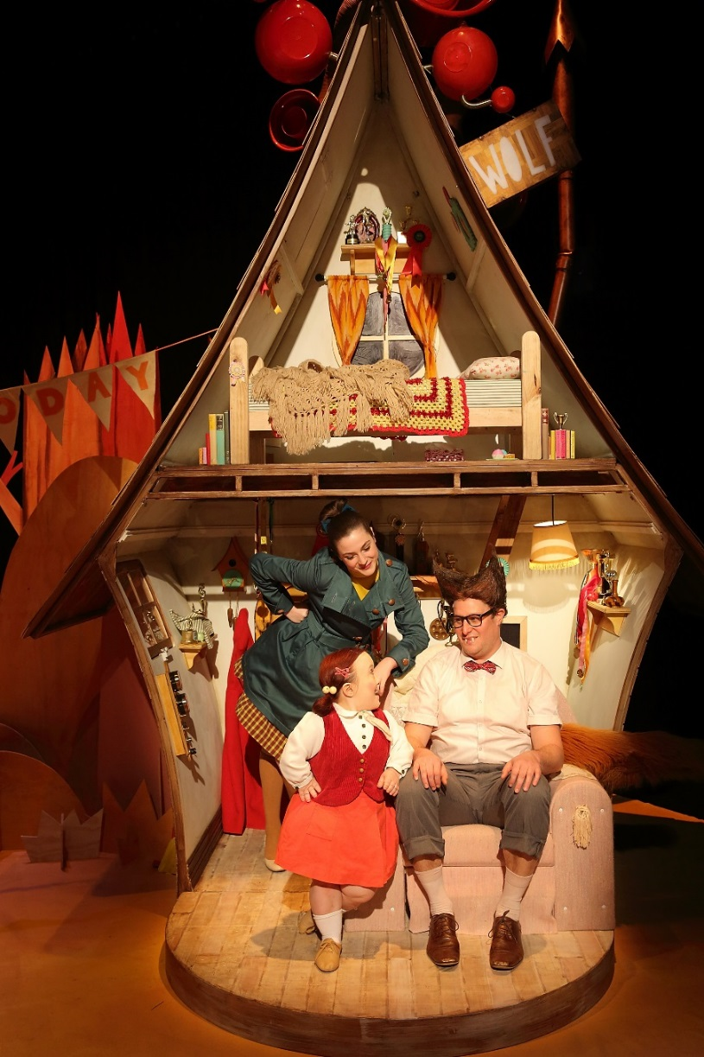

**Extensions -**

* Act out the story! Give each student a two-sided picture card. Each card contains an animal on one side and its tail on the other side. Let students arrange themselves so that they are in the same order as the animals in the story. To begin, have the students show the side containing the tail only. As each animal is mentioned, students turn their cards over so that the animal can be shown.
* Let each student choose one animal from *Do You Want to Be My Friend?* and create an animal mask to use to reenact the story.
* Create a class mural of a friendship tree. Each child writes/draw their favorite attribute of a friend on a leaf, and all of them are put together on the tree.



Lesson – Big Bad/Good Wolf?

**Introduction** – Students may only be familiar with stories that make the wolf character “Big” and “Bad”, but in this performance of *Big Bad Wolf*, the character of Wolfie is a kind, loving, vegetable eating poet! In this lesson, students will identify and describe the characteristics of the wolf character and compare and contrast versions of the “Big Bad Wolf”.

**\*\*Prior Knowledge** – This lesson requires knowledge of the traditional telling of *Little* *Red Riding Hood*. If students do not know this story yet, begin by reading it for background knowledge.

**Objectives**:

The student will infer character traits from visual images and written descriptions.

The student will compare and contrast two versions of *Little Red Riding Hood*, and the wolf character.

**Materials Needed**: *Little Red Riding Hood/the Wolf's Tale (Upside Down Tales)* by Della Rowland, images of “good” and “bad” wolf characters, image of Wolfie

**Instructional Procedures:**

* When students enter, have two images posted in front of the classroom. One of a “bad” wolf, and one of a “good” wolf. (An example of each are on the next page.) Ask them to describe each of the images, and to explain their reasons. For example, one of them could be described as “nice” because it is smiling.
* Discuss the concepts of "good" and "bad" in relation to characters. Ask, "What are characteristics that would make a character 'bad'? What characteristics would make a character 'good'?" Generate a list of "good" and "bad" characteristics, clarifying with students why that characteristic would make a character "good" or "bad". Remind them that characteristics can be on the outside (what a character looks like) and the inside (how a character acts).
* Consider the character of the Wolf in 2 well-known stories – *The Three Little Pigs* and *Little Red Riding Hood*. We normally hear the character described as “Big” and “Bad”. Discuss the wolf's characteristics in these stories that make us describe him that way.
* What are the characteristics of the wolf in this story?
* What details in the story help you describe the wolf?
* What events/experiences help you describe the wolf?
* How do the illustrations help you to describe the wolf?
* Is that characteristic "good" or "bad"? Why?
* Now students will hear a new version of the *Little Red Riding Hood* story, which may change their description of the wolf character. It is told from the Wolf’s perspective. Discuss - What do they think will happen in his story? Tell students to listen for the wolf's characteristics as you read.
* Read *Little Red Riding Hood/the Wolf's Tale (Upside Down Tales)* by Della Rowland. Discuss this story, and how it is the same and different from the original. Have students come up with at least 2 similarities and 2 differences in the wolf's character. Ask guiding questions: How is the wolf the same in both stories? How is he different?
* Finally, students will compare/contrast the characteristics of the wolf from the original story to the characteristics in the story you just read by using a Venn Diagram. Model for the class how to enter one similarity and one difference, then let students finish filling in the graphic organizer on their own or in pairs. For younger students, you may do this activity as a class.

**Conclusion** - Show students the image of Wolfie from the play *Big Bad Wolf* (found below). What do they notice about Wolfie? Point out some things such as the young girl smiling with him and not scared, the bow in his hair, he is smiling, etc. What do they think Wolfie will be like? Will he be more like the “good” wolf, or the “bad” wolf?

**WOLF IMAGE EXAMPLES:**

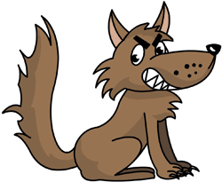

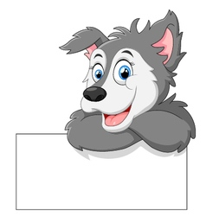

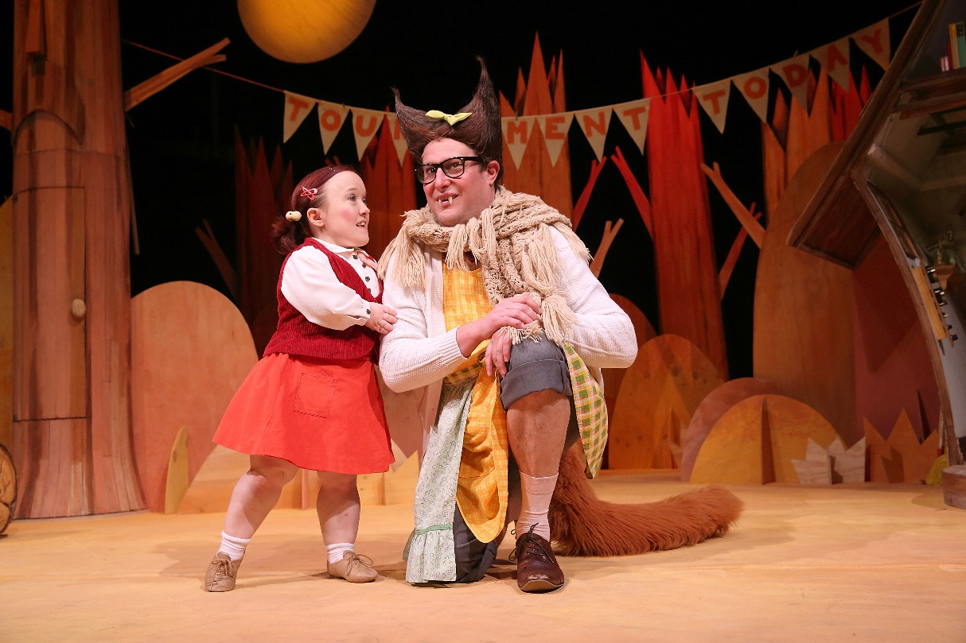



More Fun Ideas!

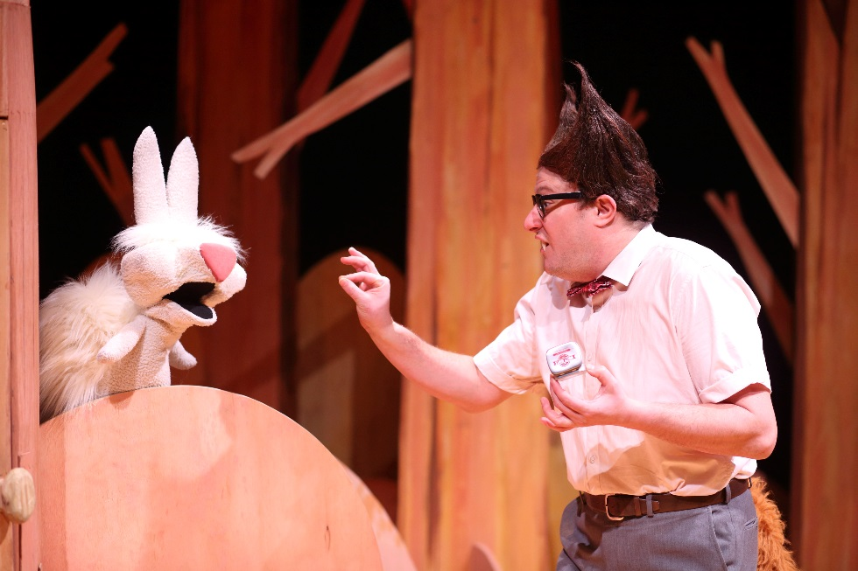

**Puppet Play** - In the production of *Big Bad Wolf*, students will see a variety of puppet techniques, from hand held (the rabbit) to talking objects (the couch and tree). Select a fairy tale and make puppets to represent the characters.

**Fairy Tale Retelling** - A large sheet paper is folded in half, like a story book. The children draw a picture of one of their favorite fairy tale characters on the front. On the inside, they dictate their retelling of the fairy tale.

**Fairy Tale Graph** - Each child writes their name on an index card, chooses a favorite fairy tale, and places their card on the pocket chart graph. Then, count and compare the results: what has the most/least/same?

**Story Book Character Parade** - Each student is encouraged to dress up as their favorite character and walks the halls in a parade to show off their costumes.

**Real or Pretend?** - Make two signs: One that says REAL and one that says PRETEND. Find pictures or use stuffed animals or puppets. Give each child a picture or stuffed animal. Place the cards REAL and PRETEND in the middle of circle, perhaps near 2 bins or laundry baskets. Take turns talking about each one. After discussing each one, ask, "Is this REAL or PRETEND?" and have child place in appropriate basket. Suggestions: Real--any woodland animal. Pretend--Big Bad Wolf; Troll (from 3 Billy Goats Gruff); Beast (from Beauty and the Beast); unicorn

**Wolves vs. Dogs** - Many wolves look like dogs and many dogs (think huskies and malamutes) look like wolves! Show pictures of both and talk about their similarities and differences. Write them on a Venn Diagram Chart where you have Wolves on the left, Dogs on the right and the things that are similar will be in the connecting middle.

**Let's Howl!** - Get those wiggles out and have students move around the room like a wolf. Then let them howl like a wolf! Discuss why wolves howl, talking about how animals communicate.

**Peter and the Wolf** – go deeper in your study of wolves by listening to recording of *Peter and Wolf* by Prokofiev and discussing how musical sounds can create the characters. Does the instrument used for the wolf sound like a “bad” wolf or a “good” wolf character? Explain your reasons.



About the Actors



**PATRICK GRAHAM** - Patrick graduated from AC Arts in 2001 and since then, has worked as a freelance actor and company member of Floogle Theatre Company. For Floogle Patrick has performed in *One Long Night in the Land of Nod* (Best New Work 2005 Advertiser Award) also shown at The Old Fitzroy with the Tamarama Rock Surfers, *Black Crow Lullabies* (Best Original Work

2006 Adelaide Fringe Award), and *The Homecoming* (Advertiser Oscart Award, Actor on the Rise 2007). For Windmill Theatre Patrick has appeared in *The Wizard of Oz, Fugitive* and *Boom Bah!* Other theatre credits include State Theatre Company of SA for *Blasted* (2013), *Buried Child*, *Three Sisters, The Misanthrope* (2012), *The   Cripple   of   Inishmaan* (2008), *Lion Pig Lion* (2007) and *Equus* (2000) and *The Night Before Christmas* for Bakehouse Theatre. Patrick’s television credits include *Blue   Heelers*,   *Stingers*,   *Fergus McPhail* and *McLeod’s Daughters*. Film credits include *The King is Dead* (Rolf De Heer) and *Angela’s Decision* (Matt King).



**EMMA J HAWKINS** - Emma ran away with the circus in 2009 as a tap-dancing, stilt-walking acrobat in CircusOz. She has continued to perform her circus duo, *Little and Large*, with strongwoman Mel Fyfe. As a short statured performer with a bag of tricks bigger than herself, Emma has performed across Australia in events, festivals and productions, from Shakespeare to burlesque, to appearances as The Divine Miss Em. She recently played Fleck in the Australian premiere of Andrew Lloyd Webber's *Love Never Dies* (Green Room award nomination). Emma’s acting career includes Round Earth Company’s *King Lear*, Sydney Theatre Company’s *The Maids and Volpone*, and Arena Theatre’s *Eat Your Young*. Her physical theatre includes *PlazaReal* (Branch Nebula & UTP) and her own award-winning dance theatre piece, *One More Than One*. She’s appeared in *The Fireraisers* and *Sideshow Alley.* Emma’s own company, Atypical Theatre Company embraces fair representation of disability in the arts. As a freelance artist, Emma has performed in *Take Up Thy Bed & Walk* and Biba’s *Wizard of Oz Burlesque*

*Show*. Her television and film experience includes *Bogan Pride*, *Pizza* (SBS) and *Stars Wars*.

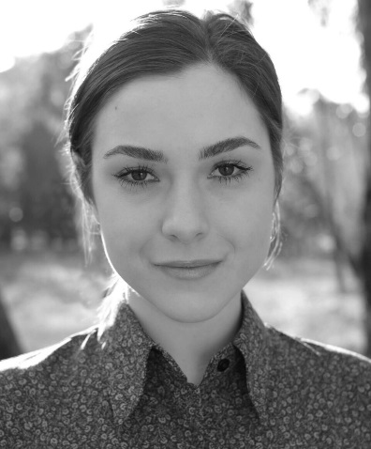

**KATE CHEEL** - Kate is a recent graduate of AC Arts. She has previously worked with State Theatre Company of SA in productions of *Three Sisters* and *The Glass Menagerie*, for which she was awarded 2012 Emerging Artist of the Year by the Adelaide Critics Circle, and also performed in *Hedda Gabbler*. She has recently completed work on her first feature film, *One Eyed Girl*.